Towards Effective Bug Triage with Software Data Reduction Techniques
ABSTRACT:
Software companies spend over 45 percent of cost in dealing with software bugs. An inevitable step of fixing bugs is bug triage, which aims to correctly assign a developer to a new bug. To decrease the time cost in manual work, text classification techniques are applied to conduct automatic bug triage. In this paper, we address the problem of data reduction for bug triage, i.e., how to reduce the scale and improve the quality of bug data. We combine instance selection with feature selection to simultaneously reduce data scale on the bug dimension and the word dimension. To determine the order of applying instance selection and feature selection, we extract attributes from historical bug data sets and build a predictive model for a new bug data set. We empirically investigate the performance of data reduction on totally 600,000 bug reports of two large open source projects, namely Eclipse and Mozilla. The results show that our data reduction can effectively reduce the data scale and improve the accuracy of bug triage. Our work provides an approach to leveraging techniques on data processing to form reduced and high-quality bug data in software development and maintenance.
EXISTING SYSTEM:
- To investigate the relationships in bug data, Sandusky et al. form a bug report network to examine the dependency among bug reports.
- Besides studying relationships among bug reports, Hong et al. build a developer social network to examine the collaboration among developers based on the bug data in Mozilla project. This developer social network is helpful to understand the developer community and the project evolution.
- By mapping bug priorities to developers, Xuan et al. identify the developer prioritization in open source bug repositories. The developer prioritization can distinguish developers and assist tasks in software maintenance.
- To investigate the quality of bug data, Zimmermann et al. design questionnaires to developers and users in three open source projects. Based on the analysis of questionnaires, they characterize what makes a good bug report and train a classifier to identify whether the quality of a bug report should be improved.
- Duplicate bug reports weaken the quality of bug data by delaying the cost of handling bugs. To detect duplicate bug reports, Wang et al. design a natural language processing approach by matching the execution information.
DISADVANTAGES OF EXISTING SYSTEM:
- Traditional software analysis is not completely suitable for the large-scale and complex data in software repositories.
- In traditional software development, new bugs are manually triaged by an expert developer, i.e., a human triager. Due to the large number of daily bugs and the lack of expertise of all the bugs, manual bug triage is expensive in time cost and low in accuracy.

PROPOSED SYSTEM:
- In this paper, we address the problem of data reduction for bug triage, i.e., how to reduce the bug data to save the labor cost of developers and improve the quality to facilitate the process of bug triage.
- Data reduction for bug triage aims to build a small-scale and high-quality set of bug data by removing bug reports and words, which are redundant or non-informative.
- In our work, we combine existing techniques of instance selection and feature selection to simultaneously reduce the bug dimension and the word dimension. The reduced bug data contain fewer bug reports and fewer words than the original bug data and provide similar information over the original bug data. We evaluate the reduced bug data according to two criteria: the scale of a data set and the accuracy of bug triage.
- In this paper, we propose a predictive model to determine the order of applying instance selection and feature selection. We refer to such determination as prediction for reduction orders.
- Drawn on the experiences in software metrics,1 we extract the attributes from historical bug data sets. Then, we train a binary classifier on bug data sets with extracted attributes and predict the order of applying instance selection and feature selection for a new bug data set.
ADVANTAGES OF PROPOSED SYSTEM:
- Experimental results show that applying the instance selection technique to the data set can reduce bug reports but the accuracy of bug triage may be decreased.
- Applying the feature selection technique can reduce words in the bug data and the accuracy can be increased.
- Meanwhile, combining both techniques can increase the accuracy, as well as reduce bug reports and words.
- Based on the attributes from historical bug data sets, our predictive model can provide the accuracy of 71.8 percent for predicting the reduction order.
- We present the problem of data reduction for bug triage. This problem aims to augment the data set of bug triage in two aspects, namely a) to simultaneously reduce the scales of the bug dimension and the word dimension and b) to improve the accuracy of bug triage.
- We propose a combination approach to addressing the problem of data reduction. This can be viewed as an application of instance selection and feature selection in bug repositories.
- We build a binary classifier to predict the order of applying instance selection and feature selection. To our knowledge, the order of applying instance selection and feature selection has not been investigated in related domains.

SYSTEM ARCHITECTURE:
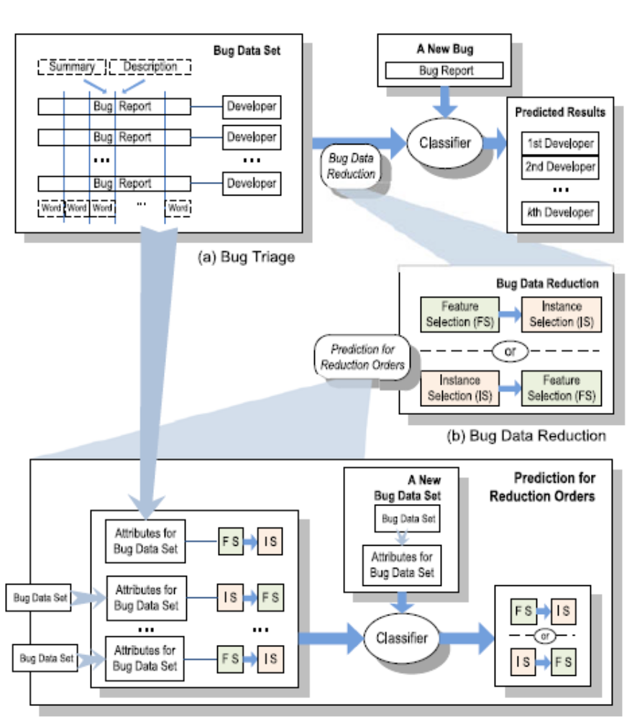
MODULES:
- Dataset Collection
- Preprocessing Method
- Feature Selection/ Instance Selection
- Bug Data Reduction
- Performance Evaluation

MODULES DESCSRIPTION:
Dataset Collection:
To collect and/or retrieve data about activities, results, context and other factors. It is important to consider the type of information it want to gather from your participants and the ways you will analyze that information. The data set corresponds to the contents of a single database table, or a single statistical data matrix, where every column of the table represents a particular variable. after collecting the data to store the Database.

Preprocessing Method:
Data Preprocessing or Data cleaning, Data is cleansed through processes such as filling in missing values, smoothing the noisy data, or resolving the inconsistencies in the data. And also used to removing the unwanted data. Commonly used as a preliminary data mining practice, data preprocessing transforms the data into a format that will be more easily and effectively processed for the purpose of the user.

Feature Selection/ Instance Selection:
The combination of instance selection and feature selection to generate a reduced bug data set. We replace the original data set with the reduced data set for bug triage. Instance selection is a technique to reduce the number of instances by removing noisy and redundant instances. By removing uninformative words, feature selection improves the accuracy of bug triage. It recover the accuracy loss by instance selection.

Bug Data Reduction:

The data set can reduce bug reports but the accuracy of bug triage may be decreased. It improves the accuracy of bug triage. It tends to remove these words to reduce the computation for bug triage. The bug data reduction to reduce the scale and to improve the quality of data in bug repositories. It reducing duplicate and noisy bug reports to decrease the number of historical bugs.

Performance Evaluation:

In this Performance evaluation, algorithm can provide a reduced data set by removing non-representative instances. The quality of bug triage can be measured with the accuracy of bug triage. to reduce noise and redundancy in bug data sets.

SYSTEM REQUIREMENTS:
HARDWARE REQUIREMENTS:

- System : Pentium IV 2.4 GHz.
- Hard Disk : 40 GB.
- Floppy Drive : 1.44 Mb.
- Monitor : 15 VGA Colour.
- Mouse : Logitech.
- Ram : 512 Mb.

SOFTWARE REQUIREMENTS:

- Operating system : Windows XP/7.
- Coding Language : JAVA
- IDE : Netbeans 7.4
- Database : MYSQL
REFERENCE:
Jifeng Xuan, He Jiang, Member, IEEE, Yan Hu, Zhilei Ren, Weiqin Zou, Zhongxuan Luo, and Xindong Wu, Fellow, IEEE, “Towards Effective Bug Triage with Software Data Reduction Techniques”, IEEE TRANSACTIONS ON KNOWLEDGE AND DATA ENGINEERING, VOL. 27, NO. 1, JANUARY 2015.

